Supplementary material

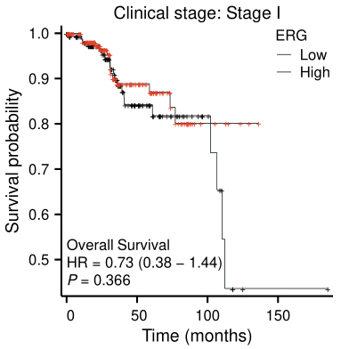

Supplementary Fig. 1. Kaplan Meier plotter analysis showed a prognostic relationship between ERG expression and clinical stage I in EC patients. HR: hazard ratio; *ERG*: erythroblast transformation-specific related gene.

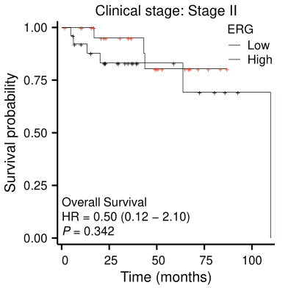

Supplementary Fig. 2. Kaplan Meier plotter analysis showed a prognostic relationship between ERG expression and clinical stage Ⅱ in EC patients. HR: hazard ratio; *ERG*: erythroblast transformation-specific related gene.

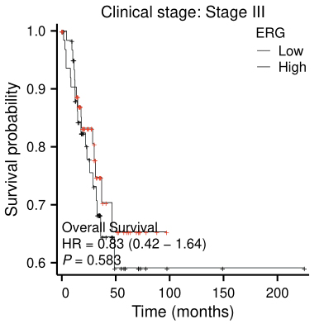

Supplementary Fig. 3. Kaplan Meier plotter analysis showed a prognostic relationship between ERG expression and clinical stage Ⅲ in EC patients. HR: hazard ratio; *ERG*: erythroblast transformation-specific related gene.

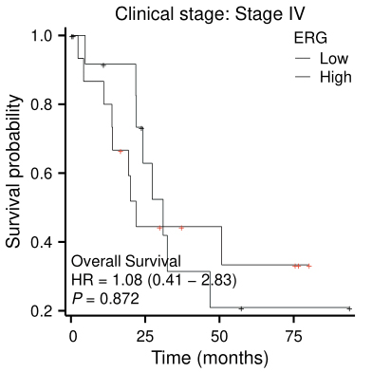

Supplementary Fig. 4. Kaplan Meier plotter analysis showed a prognostic relationship between ERG expression and clinical stage Ⅳ in EC patients. HR: hazard ratio; *ERG*: erythroblast transformation-specific related gene.

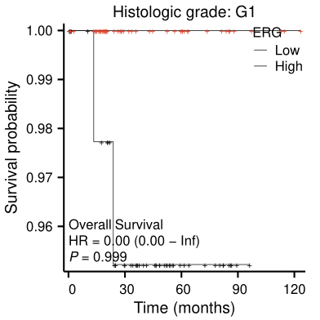

Supplementary Fig. 5. Kaplan Meier plotter analysis showed a prognostic relationship between ERG expression and Histologic grade G1 in EC patients. HR: hazard ratio; *ERG*: erythroblast transformation-specific related gene.

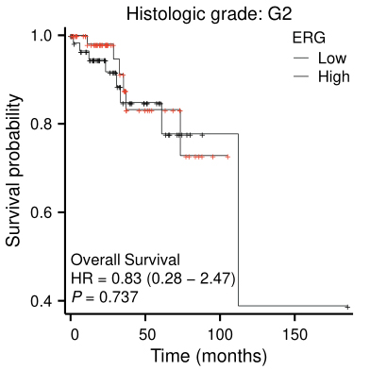

Supplementary Fig. 6. Kaplan Meier plotter analysis showed a prognostic relationship between ERG expression and Histologic grade G2 in EC patients. HR: hazard ratio; *ERG*: erythroblast transformation-specific related gene.

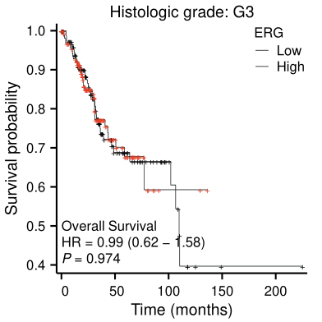

Supplementary Fig. 7. Kaplan Meier plotter analysis showed a prognostic relationship between ERG expression and Histologic grade G3 in EC patients. HR: hazard ratio; *ERG*: erythroblast transformation-specific related gene.

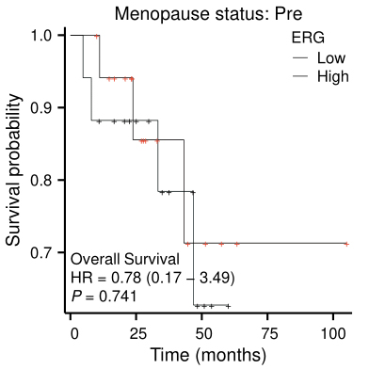

Supplementary Fig. 8. Kaplan Meier plotter analysis showed a prognostic relationship between ERG expression and Pre-Menopause in EC patients. HR: hazard ratio; *ERG*: erythroblast transformation-specific related gene.

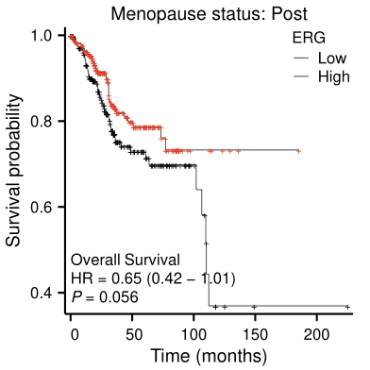

Supplementary Fig. 9. Kaplan Meier plotter analysis showed a prognostic relationship between ERG expression and Post-Menopause in EC patients. HR: hazard ratio; *ERG*: erythroblast transformation-specific related gene.

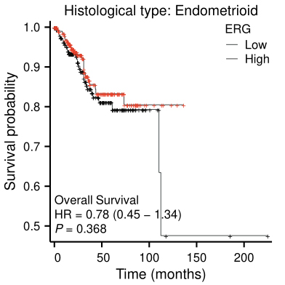

Supplementary Fig. 10. Kaplan Meier plotter analysis showed a prognostic relationship between ERG expression and endometrioid histological type in EC patients. HR: hazard ratio; *ERG*: erythroblast transformation-specific related gene.

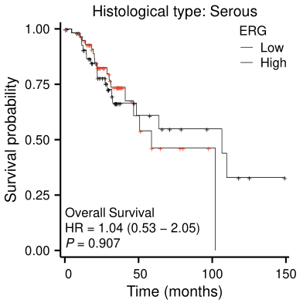

Supplementary Fig. 11. Kaplan Meier plotter analysis showed a prognostic relationship between ERG expression and serous histological type in EC patients. HR: hazard ratio; *ERG*: erythroblast transformation-specific related gene.

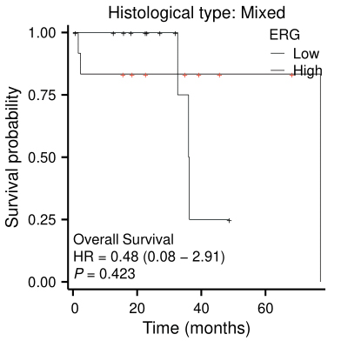

Supplementary Fig. 12. Kaplan Meier plotter analysis showed a prognostic relationship between ERG expression and mixed histological type in EC patients. HR: hazard ratio; *ERG*: erythroblast transformation-specific related gene.

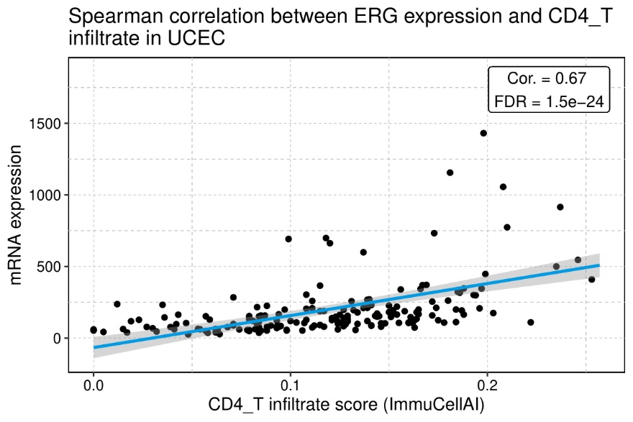

Supplementary Fig. 13. Correlation between tumour *ERG* expression and CD4+ T cells. *ERG*: erythroblast transformation-specific related gene; FDR: false discovery rate; CD: cluster of differentiation.

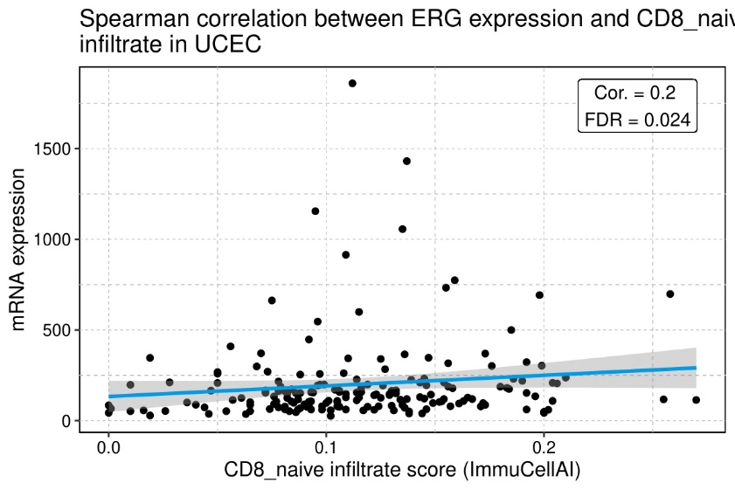

Supplementary Fig. 14. Correlation between tumour *ERG* expression and CD8+ T cells. *ERG*: erythroblast transformation-specific related gene; FDR: false discovery rate; CD: cluster of differentiation.

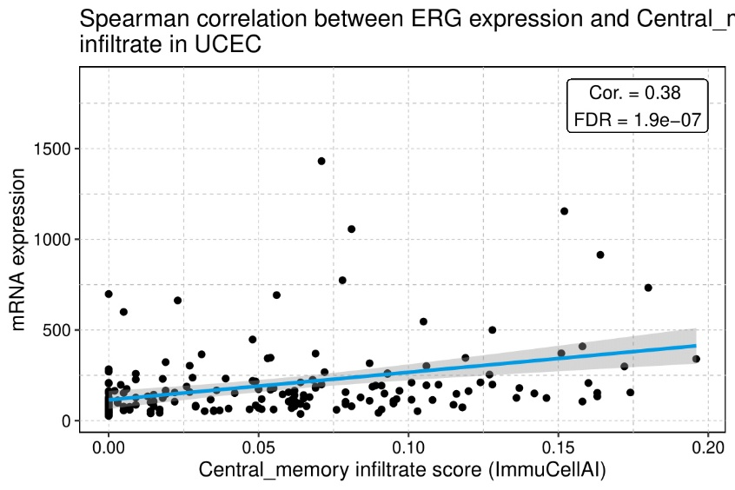

Supplementary Fig. 15. Correlation between tumour *ERG* expression and central memory T cells. *ERG*: erythroblast transformation-specific related gene; FDR: false discovery rate.

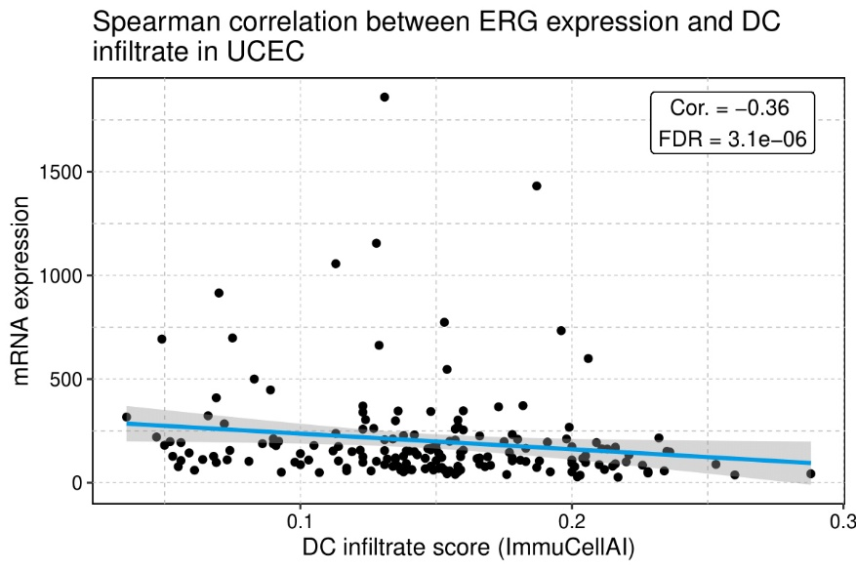

Supplementary Fig. 16. Correlation between tumour *ERG* expression and dendritic cell. *ERG*: erythroblast transformation-specific related gene; FDR: false discovery rate; DC: dendritic cell.

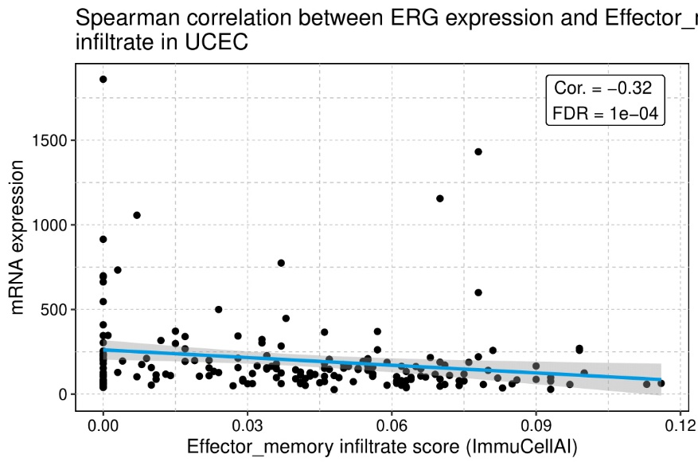

Supplementary Fig. 17. Correlation between tumour *ERG* expression and effector memory T cell. *ERG*: erythroblast transformation-specific related gene; FDR: false discovery rate.

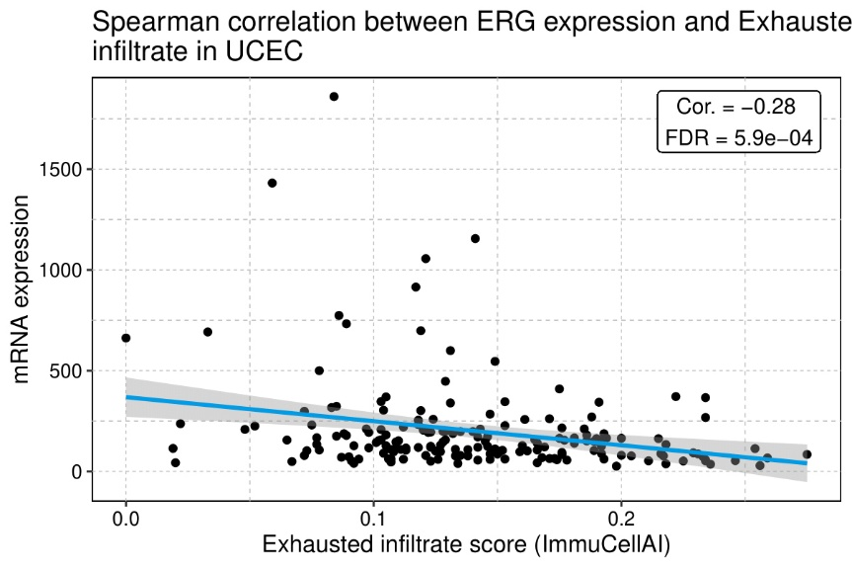

Supplementary Fig. 18. Correlation between tumour *ERG* expression and exhausted T cell. *ERG*: erythroblast transformation-specific related gene; FDR: false discovery rate.

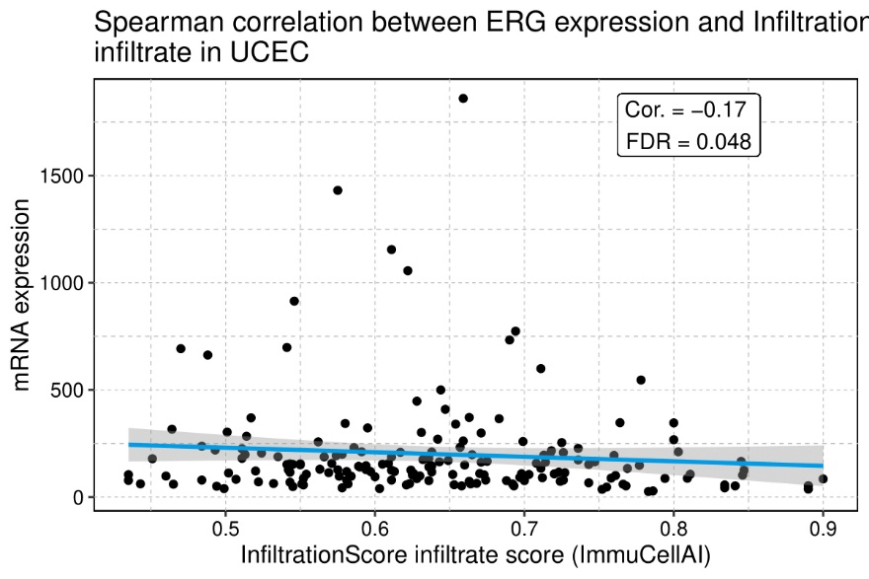

Supplementary Fig. 19. Correlation between tumour *ERG* expression and infiltration score. *ERG*: erythroblast transformation-specific related gene; FDR: false discovery rate.

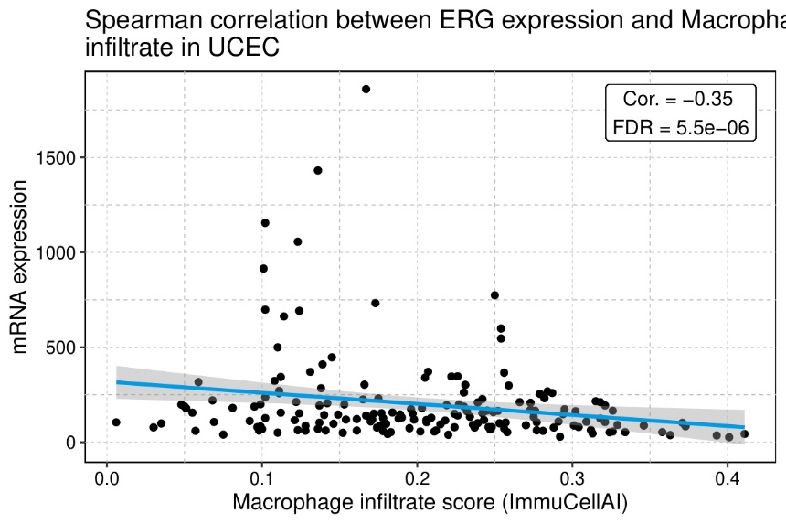

Supplementary Fig. 20. Correlation between tumour *ERG* expression and macrophage. *ERG*: erythroblast transformation-specific related gene; FDR: false discovery rate.

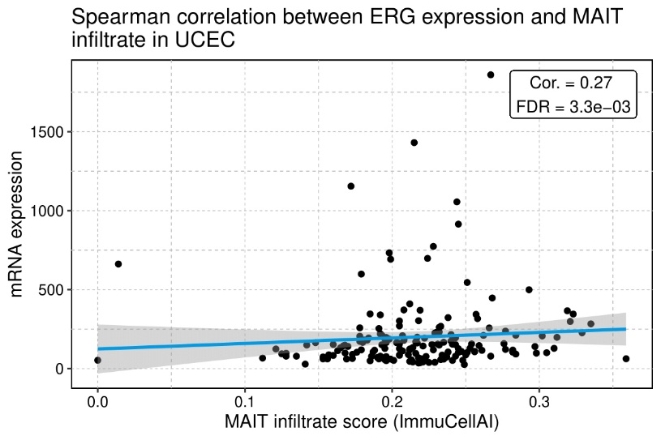

Supplementary Fig. 21. Correlation between tumour *ERG* expression and MAIT cells. *ERG*: erythroblast transformation-specific related gene; FDR: false discovery rate; MAIT: mucosal-associated invariant T.

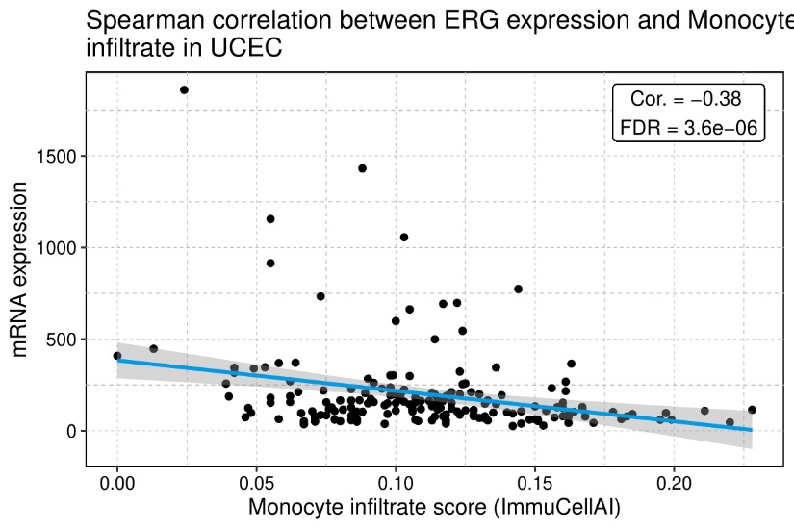

Supplementary Fig. 22. Correlation between tumour *ERG* expression and monocyte. *ERG*: erythroblast transformation-specific related gene; FDR: false discovery rate.

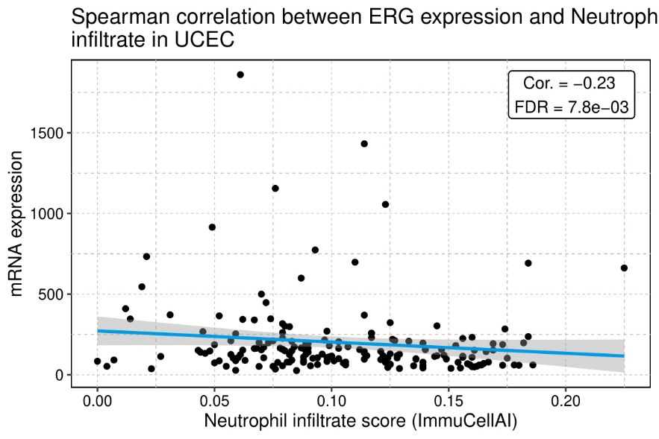

Supplementary Fig. 23. Correlation between tumour *ERG* expression and neutrophil. *ERG*: erythroblast transformation-specific related gene; FDR: false discovery rate.

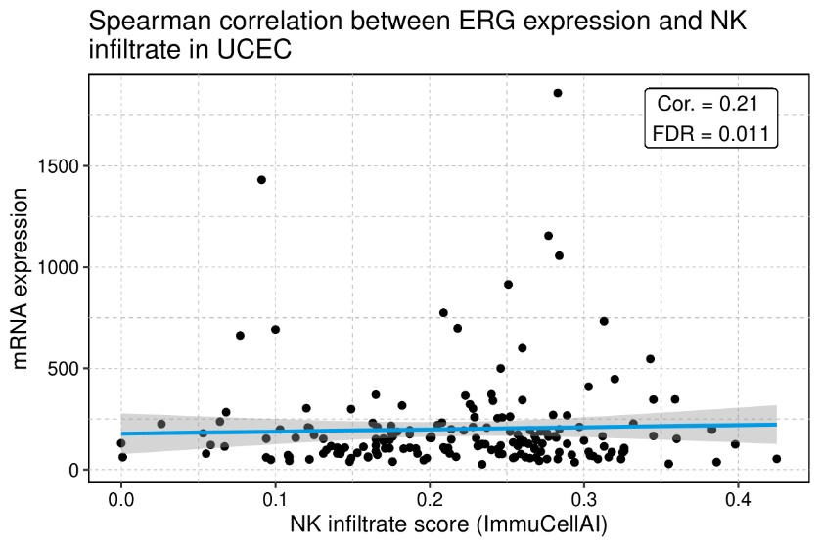

Supplementary Fig. 24. Correlation between tumour *ERG* expression and NK cells. *ERG*: erythroblast transformation-specific related gene; FDR: false discovery rate; NK: natural killer.

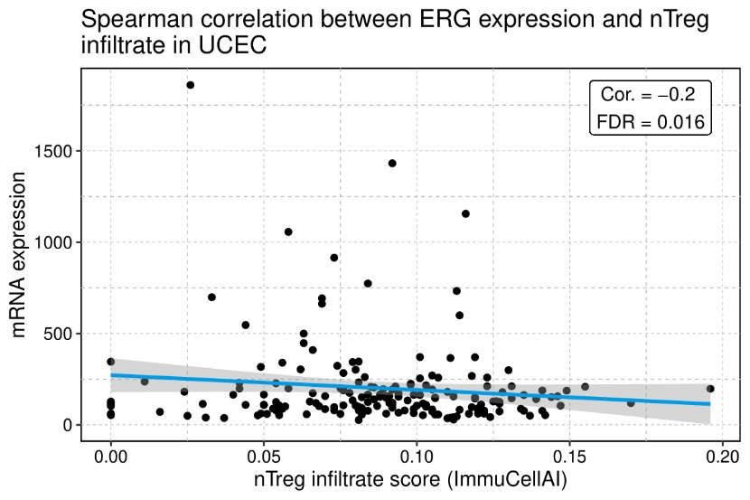

Supplementary Fig. 25. Correlation between tumour *ERG* expression and Treg cell. *ERG*: erythroblast transformation-specific related gene; FDR: false discovery rate.

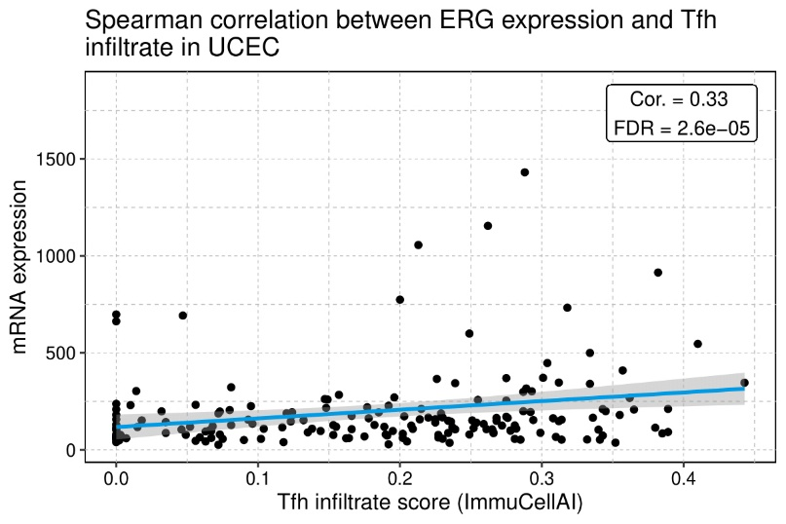

Supplementary Fig. 26. Correlation between tumour *ERG* expression and Tfh cells. *ERG*: erythroblast transformation-specific related gene; FDR: false discovery rate; Tfh: T follicular helper.

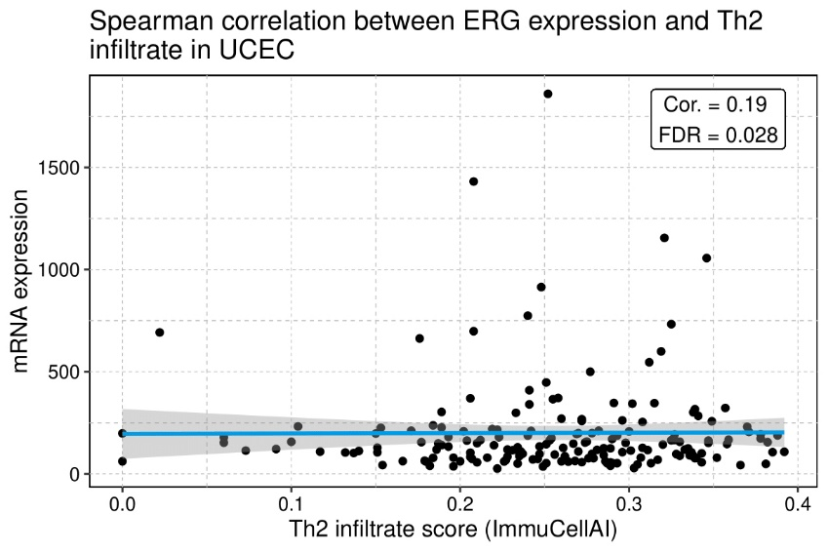

Supplementary Fig. 27. Correlation between tumour *ERG* expression and Th2 cells. *ERG*: erythroblast transformation-specific related gene; FDR: false discovery rate; Th2: T helper 2.